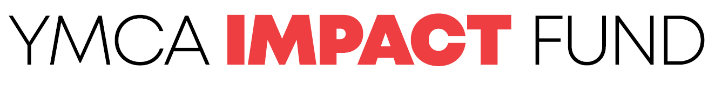

Project Title (give your proposal a descriptive name so others can quickly get a sense of what it’s about)
Project Champion (the person who leads the project) | Location(s) (i.e. lead YMCA)
Project Type (tick ONE of the following as the primary category)
☐ Innovation project (Seed Fund) | ☐ Charitable activity (Community Chest)

Who is this for? (i.e. the intended market, users, or beneficiaries of your proposed initiative) Max. 200 words

What is the need being addressed? (i.e. the under-served need or problem you’re solving for) Max. 200 words
What change are you hoping to see as a result of this initiative? (i.e. what does success look like?) Max. 200 words

What is your proposed solution? (or, if you don’t yet know the answer, what’s your proposed approach?) Max. 200 words

Why is the YMCA the right organisation to be doing this? (i.e. why us, why now?)

What other organisation(s) would you work with in doing this? (if any)
What other Y staff would be part of your proposed project team? (if it was approved)

When would the project start and finish? (i.e. anticipated timeframes)

What resources would you need from the YMCA to do this?
Time (to work on the project)
Funding (for expenses)
Other

Is there anything else you’d like the Selection Panel to consider?

CHECKLIST

Please consider the following success factors, and tick all that apply:

Essential Criteria:
☐ I’ve spoken with my manager (and/or a senior executive) about this proposal.
☐ This proposal is outside of the scope of what my team or centre could just decide to do anyway (as part of our normal business / activities / budget).
☐ I’m confident this proposal aligns with the YMCA’s mission, strategy, and values.
☐ I don’t have any conflicts of interest in what I’ve proposed.
☐ The initiative is unlikely to be seen as divisive, political, or cause unwelcome controversy.
☐ I believe the idea is feasible (i.e. technically, it can be done in practice).
☐ I’ve considered any safety and safeguarding challenges associated with this initiative.
☐ I’m prepared to capture information during the project, report on progress, and capture the lessons learned at the end so that others might benefit from the experience.
☐ I’m prepared to profile what we’re doing through a case study or other form of storytelling.

Ideal criteria:
☐ I see ways in which this idea might become financially self-sustaining beyond the pilot.
☐ I see potential for this idea to grow (or scale) if it proves to be effective.

NEXT STEPs

Once you’ve completed your proposal, please email it to impact@ymcasa.org.au. You may be asked for some clarifications if any further information is needed.

Thereafter, it will be considered by the Selection Panel and you’ll be notified of the outcome in due course.

Thank you for your desire to make a difference and for taking the time to propose your idea.

